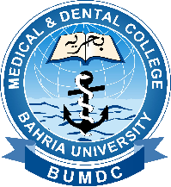
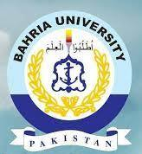
4th BUMDC INTERNATIONAL CONFERENCE
8th-13th June 2021
Healthcare: Challenges & Innovations
Registration form
Bahria University Medical & Dental College, Karachi

Please highlight:
- Attend Scientific Session
- Paper Presentation in Scientific Session
- Attend Scientific Webinar Session
- Paper Presentation in Webinar Session
- Participation in Workshop
- Poster Presentation
Name:
Qualification:
Specialty:
Designation:
Institute:
Contact Number:
Email:
Which scientific session you want to attend?
- Basic Medical Sciences
- Clinical Medical Sciences
- Dentistry
- Allied Health Sciences

SUBMIT:
1. Conference registration form at:
2. Paper presentation abstract form at:
conference.bumdc@bahria.edu.pk by 17th May 2021

SUBMIT:
1. Poster competition abstract form at: confposter.bumdc@bahria.edu.pk by 17th May 2021
2. Workshop Participation form at: confworkshop.bumdc@bahria.edu.pk by 17th May 2021

- Registration is mandatory & Free
- First come first serve basis will be followed for all categories (attending, paper presentation, poster presentation, workshop participation)

