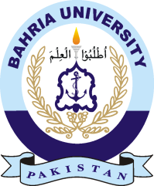

**COURSE(S) REGISTRATION FOR MBA WEEKEND SPRING, 2018**

**Discovering Knowledge MBA Weekend Program**

1. Spring Semester 2018 for ***MBA Weekend program*** is scheduled to commence w.e.f. Saturday 5 May 2018. Online course registration will take place as per following schedule:



**ONLINE COURSE REGISTRATION STARTS FROM 30 April 2018 LAST DATE OF ONLINE COURSE REGISTRATION 05 May 2018**

1. All eligible students of **MBA Weekend program** are advised to get themselves registered online from April 30, 2018. You are also advised to complete your course registration before last date and get fee voucher online.

3. No Registration cases will be entertained after due date.

4. Timetable will be uploaded the website [bahria.edu.pk](http://www.bahria.edu.pk)/bukc by 30 April 2018.

5. Any changes in the course registration owing to some genuine reasons will be allowed till the end of first week prior to commencement of the classes. No changes will be entertained after this date with the approval of HoD (MS).