|  |
| --- |
| **“Preparing For Tomorrow”** |
|  |

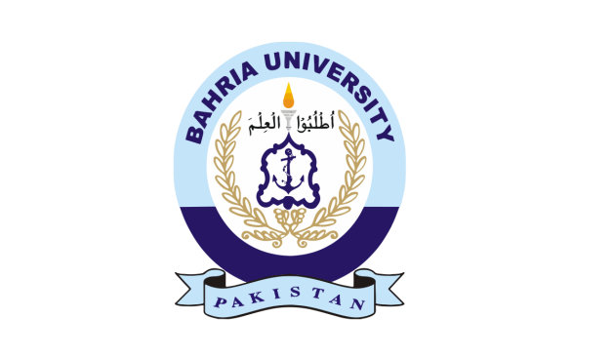



**About  
BAHRIA SOCIETY OF PROFESSIONAL COMMUNICATION:**

BSPC is a professional student society functioning at Bahria University (Karachi Campus) focusing on developing the communication skills of its members. BSPC organizes and conducts workshops, seminars and many other key events to ensure members develop professional communication and presentation skills that would help them after graduation.

BSPC comprises of the following departments:

- Marketing and Promotions

- Web and Publications

- Training and Development

- Treasury

-D-Factor

-Designing

-Internal and PR



**About the Event:**

Keeping ourselves engaged and mentally stimulated is very important for our overall wellbeing. It is especially important to consciously make an effort towards this as we age. We at the BSPC conduct workshops and other events throughout the year to promote learning and healthy experience. We get experts in their fields to conduct these workshops.

This time BSPC is organizing **workshop** “preparing for tomorrow” in collaboration with **Training & Consultancy Services**. This workshop is designed to help students at any level to increase their communication skills and creative thinking. This workshop will give them precise, applicable ideas ready for immediate implementation.

**Heirloom Table**

|  |  |
| --- | --- |
| Workshop | Preparing For Tomorrow |
| Date | **27th February, 2018** |
| Learning Partner | **Training & Consultancy Services** |
| Event Audience | **500-600** |
|  |  |
| Campus Audience | **4000+** |
| Speakers | **Shehroz Suzuki, Samad Abbas** |
| Venue | **Al-Beruni Auditorium, Bahria University Karachi Campus** |