|  |
| --- |
| DOCUFLIX’17 |
| **Organized by the Bahria Society for Professional Communication (BSPC) at Bahria University Karachi Campus.** |
|  |
|  |

6th December 2017

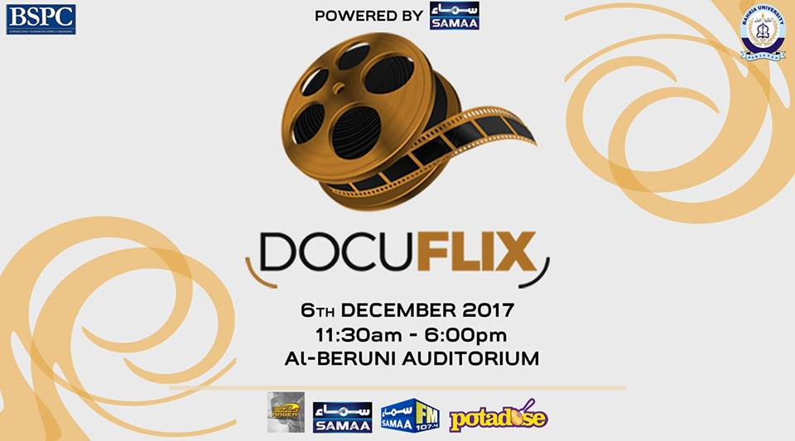

Keeping up with the tradition of successfully organising unique and innovative events in the university, this year too BSPC came up with the idea of staging a one of its kind event that would give the opportunity to students to explore and utilise their potentials in a new way. This year the society introduced a first of its kind event in the university titled ***DOCUFLIX***. The event featured documentaries made by students on topics such as ***phobia, obsession, culture*** ***and personalities.***

******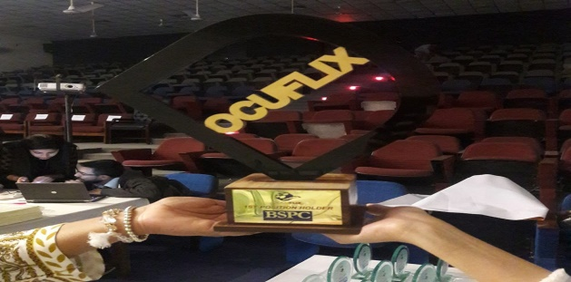

The event took place on the ***6th of Dec at Al Beruni Auditorium*** in ***the Bahria University Campus.*** The participants at the event were students of Management Sciences Department from the second and third semesters respectively.

The event featured renowned names from Pakistan’s television industry as judges that included ***Mr. Usman Mazhar and Miss Kaif Ghazanavi.*** The main highlight of the event was the guest speaker session by YouTube sensation and a popular cinematographer and footballer ***Irfan JUNEJO.***

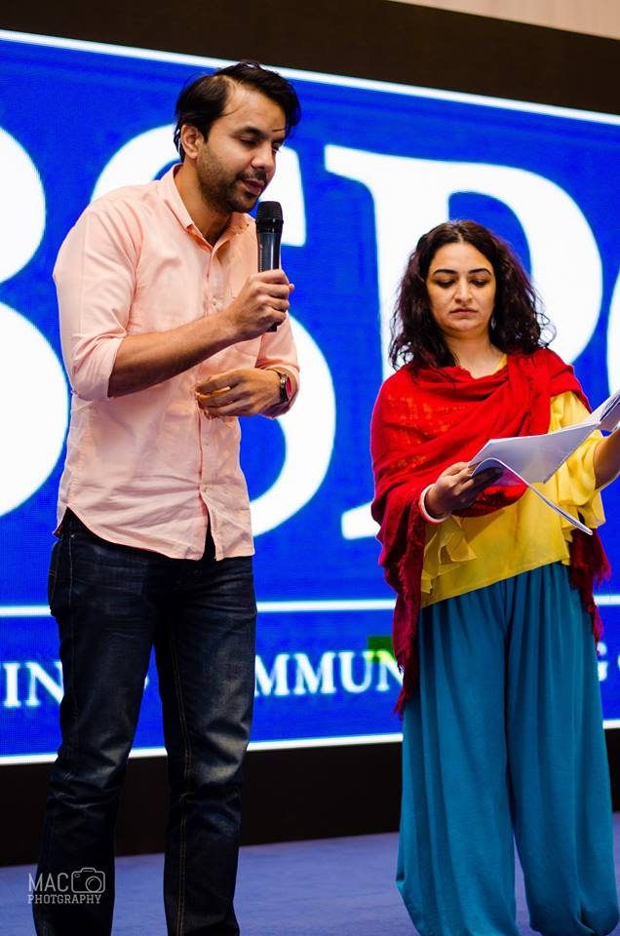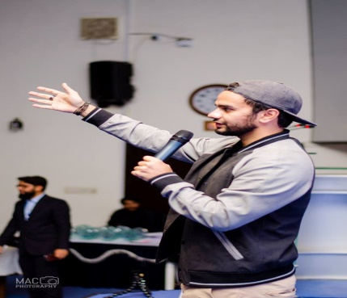

The event began with the recitation of the holy Quran followed by the national anthem of Pakistan. Thereafter a brief insight about BSPC and the event were given by our host ***Waqas Rafaqat***. This was followed by a Cake cutting ceremony on the auspicious occasion of the 7th anniversary of BSPC. The event formally began with the first documentary to be showcased that was prepared by ***BBA 2-C*** on the topic of Phobia portraying the struggles of a girl facing social phobia. Next up ***BBA 2-G*** presented a documentary on the topic personality portraying the life of a person with multiple identity disorder.

After a relaxing lunch break the event resumed and thereafter ***BBA 2-C*** exhibited the life of the martyred principal of APS Peshawar Madam Tahira Qazi. Next it was ***BBA 3-C*** who explored the importance of having inspirations.

And now it was time for the showdown the much awaited guest speaker session by ***Irfan JUNEJO*** who shared his experiences in cinematography and his life lessons. Further he appreciated the concept behind the event and the work he had witnessed by the participants.

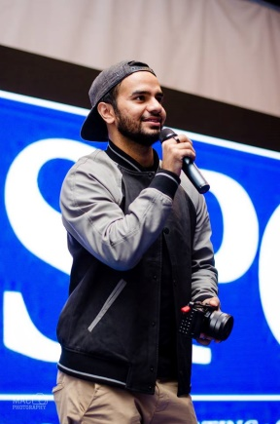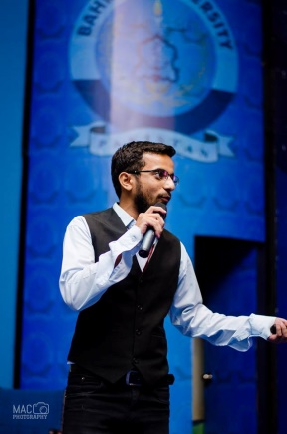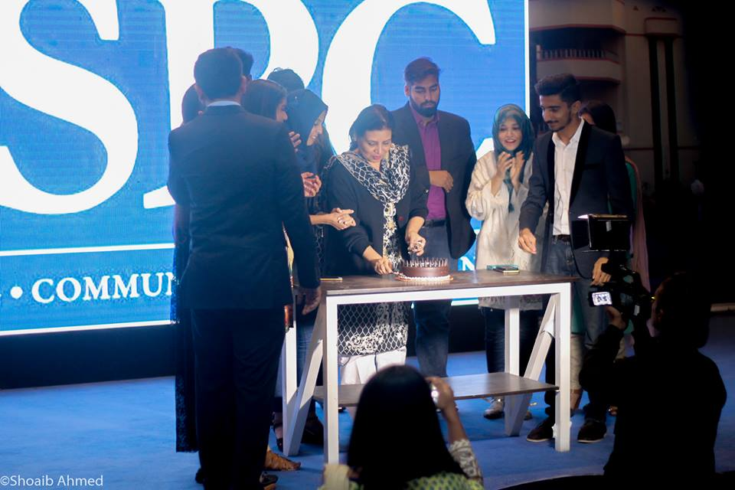

The portrayal of the amazing work by participants continued as documentary was presented on Obsessive compulsive disorder by ***BBA2-D***. Up next was ***BBA2-E*** who presented on the topic of Phobia. This was followed by a documentary on beauty obsession by ***BS (A AND F)-2*** and finally ***BBA2-B*** showcased a documentary on the culture of Pakistan. The event also featured the trailer of ***IN A TRANCE*** a short film made by one of our talented members ***Azam Awan****.*

With that the judges were given time to prepare the results and their judgements on the performances and in the meantime shields were given to members for their contributions to the society and their performances in their respective departments. Former members and alumni were also presented with Shields and letters of appreciation on behalf of BSPC by our chairperson ***Madam Afshan Saleem.***

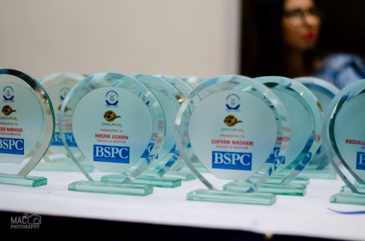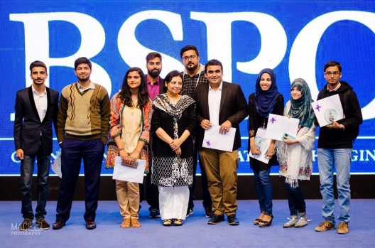

Now it was about time for the results and after some amazing work on display by the participants the judges had to choose one winner and that became ***BBA 2-D.***  The truly amazing and splendid portrayal of the topic by the winning team won the hearts of the judges and were adjudged worthy winners, the winning team was awarded with Rs10000 cash prize along with a special winner’s trophy. The judges once again were full of praises for the successful staging of the event and appreciated the innovative idea behind the event. They were extremely impressed by the work of the participating students and also had word of advice regarding the work they had done. The event closed out with an amazing performance by our talented members from ***D Factor***. 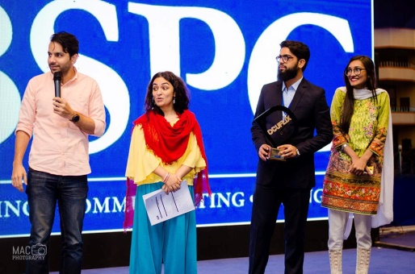 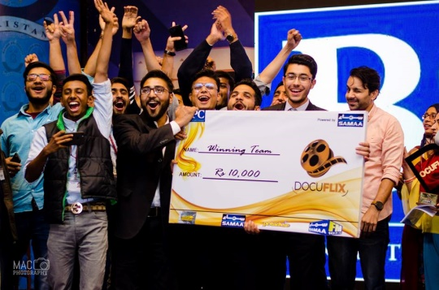

Thus DOCUFLIX finally came to close but with a commitment and promise by BSPC to be back with something more amazing and unique, something that would give students more opportunities to express their potentials and skills on a big stage.

Authored by

Web and Publications Department(BSPC)