Policy No: BUORIC-P17  Form No: BUORIC-F17 |  | 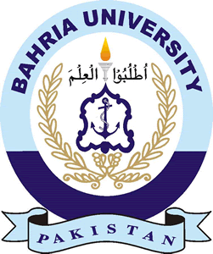  Application Form  Short Term International Research Visit  BAHRIA UNIVERSITY
1 | APPLICANT’S PROFILE
 | Name
 | Passport No. |  |  |  | CNIC No.
 | Highest Qualification
 | Designation
 | Department/Institute
 | Contact Details |  |  |  | Cell
 |  |  |  |  | Email
2 | DETAILS OF RESEARCH VISIT
 | University Name
 | Visit Dates
 | Venue (City) |  |  |  | Country
 | Department Name
 | Point of Contact at Host University/Institute |  |  |  | Name
 |  |  |  |  | Cell
 |  |  |  |  | Email
3 | Nature of Research Work to be undertaken  (Please attach additional sheets if required)
4 | UNDERTAKING BY THE APPLICANT
I hereby undertake and affirm that:
- I will join BU after completion of the short term research visit.
- I will present a detailed report on the research activities undertaken by myself during my short term research visit within 2 weeks’ of re-joining BU
- All the supporting documents submitted are authentic.

SIGNATURES OF THE APPLICANT
5 | RECOMMENDATION BY THE HEAD OF DEPARTMENT
________________________________________________________________

SIGNATURE & STAMP

6 | RECOMMENDATION BY DEAN
________________________________________________________________

SIGNATURE & STAMP

7 | RECOMMENDATION BY DIRECTOR/PRINCIPAL (CAMPUS/INSTITUTE/COLLEGE)
_________________________________________________________________________

SIGNATURE & STAMP

8 | RECOMMENDATION BY DIRECTOR GENERAL
_________________________________________________________________________

SIGNATURE & STAMP

CHECK LIST OF ATTACHMENTS
Please ensure that relevant documents are attached with the Application Form.

1 | Formal Invitation Letter from host research institute/lab | Yes | No
2 | Research Plan during the tenure of research visit | Yes | No
4 | Updated CV clearly specifying research publications and relevant experience | Yes | No

Signature of Applicant

